**Bug Report**

**Bug-1: Task Disappear After Page Refresh**

**Project Name:** To-do-MVC Project

**URL**: <https://todomvc.com/examples/react/dist/>

**Reported By:** Sunmathi

**Reported Date:** 22.05.2025

**Issue Type:** Bug

**Status:** To Do Functionality

**summary:**

The application allows user to add multiple tasks to a to-do textbox. Tasks are showed in the list. But refreshing the browser, the added tasks are lost totally.

**Steps To Reproduce:**

1.Open the URL: <https://todomvc.com/examples/react/dist/>

2.Add three tasks by typing them one by one in the input box and pressing Enter-

Task1: Search Functionality

Task2: Add To Cart Functionality

Task3: Payment Method

3. Verify that the tasks appear in the list.

4. Refresh the page using F5 or browser refresh button.

5. Observe the To-Do list after refresh.

**Expected Result:**

The added tasks from the list should remain visible after the page is refreshed.

**Actual Result:**

All tasks disappeared after the page is refreshed. To-do list becomes empty.

**Impact:**

User loses their to-do items on page reload.

Indicate that the application doesn’t persist data.

**Severity:** Critical

**Priority:** Medium

**Assignee:** To developer

**Attachment:** Screenshots

**Bug-2: Todo Input box allows Special Characters as a task names**

**Project:** To-Do-MVC Project

**URL**: <https://todomvc.com/examples/react/dist/>

**Reported By:** Sunmathi

**Reported Date:** 22.05.2025

**Issue Type:** Bug

**Status:** To Do Functionality

**summary:**

The Application permits user to add special characters as task names. which do not represent meaningful input for the to-do list.

**Steps To Reproduce:**

1.Open the URL: <https://todomvc.com/examples/react/dist/>

2. In input field enter a task name with only special characters such as @!#$%^&*?()

3. press Enter

4. Observe that the task is added to the list

**Expected Result:**

Input field should show an error message such as “Invalid Input”.

**Actual Result:**

The task with special character is added successfully without error message.

**Impact:**

Tasks with no meaningful content will affect the input validation.

**Severity:** Major

**Priority:** Medium

**Assignee:** To developer

**Attachment:**

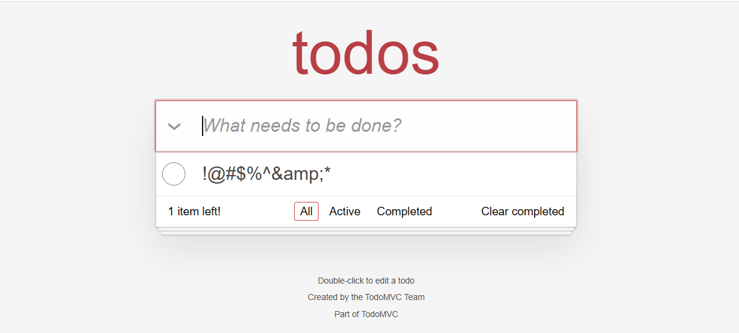

**Bug-3: “Clear Completed” Action does not display status message in the footer**

**Project:** To-Do-MVC Project

**URL**: <https://todomvc.com/examples/react/dist/>

**Reported By:** Sunmathi

**Reported Date:** 22.05.2025

**Issue Type:** Bug

**Status:** To Do Functionality

**summary:**

When a user marks the task as completed and click on the “clear completed” link button there is no conformation message in the footer.

**Steps To Reproduce:**

1.Open the application at: <https://todomvc.com/examples/react/dist/>

2. Add Multiple Tasks.

3. Mark a one or two tasks as completed by clicking the checkbox.

4.Then click on the “Clear Completed” link button.

5. Observe the foot area.

**Expected Result:**

After clicking the “Clear Completed” button, the application should show the message in the footer such as “1 task cleared” or “2 tasks removed”.

**Actual Result:**

The action is performed but no message appeared in the footer.

**Impact:**

We could not see the message in the footer. which will help us to see how many tasks are removed

**Priority:** Low

**Severity:** Minor

**Assignee:** To developer

**Attachment:** Screenshots